1. Desktop View-

Note: Priority column is kept intact to better highlight the priority

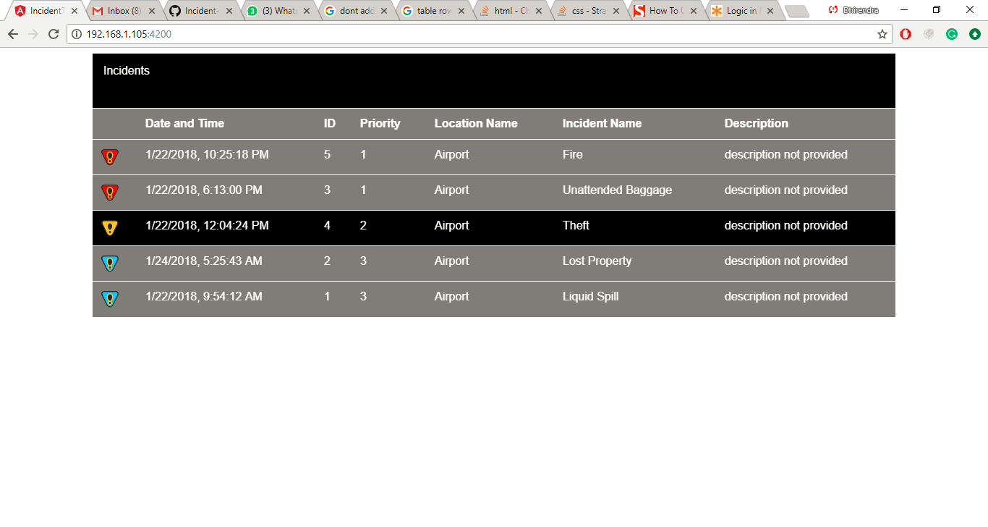

1. Mobile View

